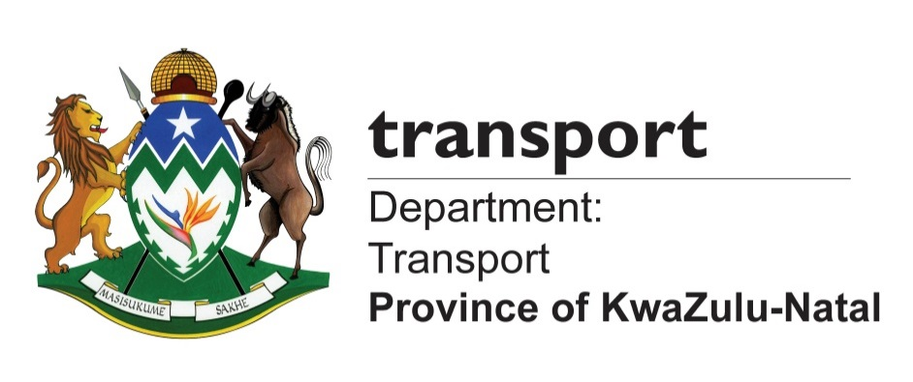

MEDIA ADVISORY

Tuesday, 28 October 2017

MEC KAUNDA CONVENES URGENT MEETING WITH LAW ENFORCEMENT HEADS TO DISCUSS AND ENHANCE FESTIVE SEASON INTEGRATED SAFETY PLAN

The KwaZulu-Natal MEC for Transport, Community Safety and Liaison, Mr. Mxolisi Kaunda, will on Wednesday (29 November 2017) address all enforcement commanders, from both the police and traffic units as part of proactive planning for the festive season.

Kaunda has called the meeting to discuss and enhance the provincial integrated festive season safety plan, which has recently been approved by the Provincial Executive Council.

The meeting of police and traffic heads is also aimed at developing clear, integrated action plans that will cascade to all corners of the province during the festive season and beyond.

It will include all commanders from the South African Police Service (SAPS), the KwaZulu-Natal Department of Transport’s Road Traffic Inspectorate (RTI) and Public Transport enforcement Services (PTES), municipal traffic heads, mayors and the Action Provincial Commissioner of the SAPS, Acting Major-General Bhekinkosi Langa. Langa will be leading the SAPS provincial management, cluster commanders, station commanders and other key units within the service.

Among the traffic enforcement delegation, there will be heads of traffic officials in the province, Road Traffic Management Corporation (RTMC), which administers National Traffic Police; the Department of Health’s Emergency Medical Services; Immigration Services; Cross-Border Agency and the Road Traffic Infringement Agency representatives.

Details of the meeting:

Date: 29 November 2017
Time: 10h00 am
Venue: Westville Correctional Service Centre, Durban

Please note that only the first session will be open to the media, but after the MECs address, the discussions will be closed.

Ends.

Media contacts:
Mluleki Mtungwa 0609741140 mluleki.mtungwa@kzntransport.gov.za
Kwanele Ncalane: 072- 803 1462/ 079- 699 5755/ Kwanele.Ncalane@kzntransport.gov.za
Nathi Sukazi 081 018 0518/ Nathi.Sukazi@kzntransport.gov.za

Website: www.kzntransport.gov.za
Twitter: @KZNTransport
Facebook: www.facebook.com/kzntransport

